

[This Photo](https://www.pngall.com/school-png/download/22801) by Unknown Author is licensed under [CC BY-NC](https://creativecommons.org/licenses/by-nc/3.0/)

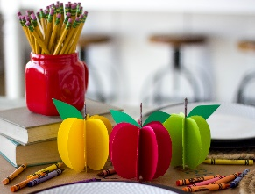

[This Photo](https://www.honeybearlane.com/2017/08/back-to-school-dinner.html) by Unknown Author is licensed under [CC BY-SA-NC](https://creativecommons.org/licenses/by-nc-sa/3.0/)

**Mrs. Stewart, Mrs, Taborda, and Mrs. Salazar**

**Room- 106 Classroom Schedule**

**2021-2022**

**8:30-8:40 Arrival Time/Breakfast**

**8:40-8:50 Greeting Time**

**8:55-9:15 Small Group**

**9:15-10:05 Outside Time**

**10:10-10:20 Planning Time**

**10:20-11:25 Work Time**

**11:25-11:35 Clean-up Time**

**11:35-11:45 Recall Time**

**11:45-12:05 Large Group Time**

**12:05-12:30 Lunch Time**

**12:30-1:30 Nap Time**

**1:30-1:35 Bathroom Time**

**1:35-1:50 Read Aloud (Story Time)**

**1:50-3:00 Work Time/Clean-up Time**

**3:05-3:15 Snack Time**

**3:15-3:20 Preparation for Dismissal**